Chapter 1 Introduction
🗺️ Overview / Roadmap
- What is the Internet? What is a protocol?
- Network Edge: Hosts, access networks, physical media
- Network Core: Packet switching, circuit switching, Internet structure
- Performance: Loss, delay, throughput
- Protocol layers & service models
- Security
- History of the Internet

What is the Internet?
1. "Nuts and Bolts" View
- Billions of devices (end systems/hosts).
- Networks: devices, routers, links managed by organizations.
- Packet switches (routers/switches) forward data packets.
- Communication links: fiber, copper, radio, satellite; bandwidth = transmission rate.

2. "Services" View
- Infrastructure supporting apps: web, streaming, video calls, games, IoT, social media.
- Provides APIs for distributed apps (like a postal service).

3. "Network of Networks"
- ISPs interconnected (local → global).
- Protocols define data exchange (HTTP, TCP, IP, WiFi, 4G/5G).
- Standards defined by RFCs, maintained by IETF.

Network Protocols
- Define message format, order, and actions on sending/receiving.
- Example: TCP connection request → HTTP GET → file transfer.

Internet Structure
- Network Edge: Hosts (clients/servers, data centers).
- Access Networks: Residential, institutional, mobile (WiFi, 4G/5G).

Access Network Types
- Cable: HFC hybrid fiber coax, shared access, asymmetric speeds (down: 40 Mbps–1.2 Gbps; up: 30–100 Mbps).
- DSL (digital subscriber line): Dedicated line via phone lines, split voice/data (down: 24–52 Mbps; up: 3.5–16 Mbps).
- Home Networks: Wired + wireless (modem, WiFi AP, router, NAT, Ethernet 1 Gbps).
- Wireless:
  - WLAN (WiFi): ~100 ft, 11–450 Mbps.
  - Cellular (4G/5G): 10s km, 10s–100s Mbps.

Enterprise & Data Center Networks
- Enterprise: Mix of wired Ethernet (100 Mbps–10 Gbps) and WiFi (11–450 Mbps).
- Data Centers: Connect many servers, very high bandwidth (10s–100s Gbps).

Hosts & Packets
- Hosts break messages into packets (L bits), sent at rate R (bandwidth).
- Packet transmission delay = L / R seconds. Tx

Links and Media
- Guided Media(signals propagate in solid media)
  - Twisted Pair (Cat 5: 100 Mbps–1 Gbps; Cat 6: 10 Gbps).
  - Coaxial Cable: broadband, 100s Mbps.
  - Fiber Optic: 10s–100s Gbps, low error, noise immune.
- Unguided Media (Wireless)( signals propagate freely,)
  - WiFi, 4G/5G, Bluetooth, Satellite (high delay ~270 ms).

Network Core
- Mesh of routers forwarding packets via packet switching.
- Forwarding (Switching): Local router action using forwarding tables (based on destination address).
- Routing: Global path determination (algorithms like Dijkstra, OSPF, BGP).

Packet Switching: Store-and-Forward
- Router receives entire packet before forwarding.
- Delay = packet size / link rate.

Packet Switching: Queueing
- Occurs if arrival rate > link capacity.
- Leads to delay increase and packet loss if buffers overflow.

Circuit Switching (Alternative to packet switching)
- Circuit switching is a method of communication where a dedicated path (circuit) is reserved for the entire duration of a session between two devices
- Uses Frequency Division (FDM) or Time Division Multiplexing (TDM).
- Pros: predictable performance.
- Cons: resource wastage during idle times.

Packet vs Circuit Switching
Aspect | Packet Switching | Circuit Switching
Resource Use | Shared, efficient for bursts | Dedicated, can waste resources
Setup | No call setup needed | Call setup required
Performance | Can have delay/congestion | Guaranteed QoS
Supported Users | More users due to sharing | Limited by fixed allocation
Example: On 1 Gbps link with users needing 100 Mbps each, packet switching supports ~35 users vs 10 for circuit switching.

🌐 Internet Structure – Network of Networks
1. Basic Idea
- Internet = interconnected ISPs.
- Hosts connect via access ISPs.
- ISPs must interconnect to enable global communication.
- Economic & policy factors add complexity.

2. Scalability Problem
- Millions of access ISPs → direct interconnection = O(N²) → not scalable.

3. Hierarchical ISP Structure
- Global Transit ISP
  - Access ISPs connect to a global ISP (customer-provider model).
  - Not sufficient alone due to competition.
- Multiple Global ISPs
  - Competing global ISPs interconnect via:
    - IXPs (Internet Exchange Points)
    - Peering links
- Regional ISPs
  - Bridge between small access ISPs and global ISPs.
  - Simplifies connectivity.
- Content Provider Networks
  - Companies (e.g., Google, Facebook) build private networks.
  - Connect directly to ISPs/IXPs → faster content delivery.

4. Modern Internet Structure
- Tier-1 ISPs: Global, well-connected, exchange traffic freely (e.g., AT&T, NTT).
- Regional ISPs: Connect access ISPs to Tier-1.
- Access ISPs: Provide service to end users.
- Content Provider Networks: Private backbones for fast delivery (e.g., Google).

dnodal = dproc + dqueue + dtrans + dprop.

🚦 Packet Delay & Loss
Causes:
- Packets queue in router buffers during congestion.
- Delay increases when arrival rate > link capacity.
- Loss occurs when buffer is full → new packets are dropped.

🚗 Caravan Analogy
Used to explain transmission & propagation delay.
- Case 1:
  - 10-car caravan (10-bit packet).
  - Toll booth (link) processes 1 car in 12 sec.
  - Cars travel 100 km at 100 km/hr.
  - Time to push entire caravan: 12 × 10 = 120 sec.
  - Time for last car to reach next booth: 1 hr.
  - Total = 62 minutes.
- Case 2:
  - Cars propagate faster: 1000 km/hr.
  - Toll booth slower: 1 min per car.
  - After 7 min, first car reaches 2nd booth while 3 cars are still at first booth.
  - Shows how transmission vs propagation can dominate differently.

📊 Queueing Delay (Revisited)
- Traffic intensity:
Traffic Intensity=(L*a)/R
where:
  - L = packet length (bits)
  - a = average packet arrival rate (packets/sec)
  - R = link bandwidth (bps)
- Observations:
  - If La/R ≈ 0 → avg. queueing delay is very small.
  - If La/R → 1 → avg. queueing delay becomes very large.
  - If La/R > 1 → more work arrives than can be serviced → infinite delay.

❌ Packet Loss
- Router buffer has finite capacity.
- If a packet arrives to a full buffer, it is dropped (lost).
- Lost packet may be:
  - Retransmitted by previous router.
  - Retransmitted by source end system.
  - Or not retransmitted at all (depends on protocol, e.g., UDP vs TCP).

📈 Throughput
Definition
- Rate at which bits are delivered from sender → receiver.
- Two types:
  - Instantaneous throughput → rate at a specific moment.
  - Average throughput → rate over a longer interval.
🚚 Throughput Summary
🔹 Basic Definitions:
- Rs = Sender rate Rc = Receiver rate R = Backbone link rate
- Throughput = actual data rate between sender and receiver (in bps)

🔸 Case 1: Rs < Rc Sender is slower →
✅ Throughput = Rs
🔸 Case 2: Rs > Rc Receiver is slower →
✅ Throughput = Rc

🛣️ Network with Shared Link: Backbone link R shared by 10 connections
- Each gets:
✅ R / 10

✅ Final Formula:
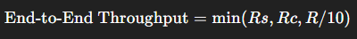
Throughput is always limited by the slowest link (bottleneck).

🔒 Network Security
- Background: Internet not originally secure; assumed trusted users. Security now essential at all layers.
- Key questions:
  - How can attackers compromise networks?
  - How to defend against attacks?
  - How to design architectures resistant to attacks?
Common Attacks:
- Packet Interception (Sniffing): In broadcast media (shared Ethernet/wireless), malicious NICs in promiscuous mode capture all packets; tools like Wireshark.
- IP Spoofing: Attacker injects packets with fake source IPs to mislead receivers.
- Denial of Service (DoS): Goal: disrupt service. Steps: select target → compromise multiple hosts (botnet) → flood target with bogus traffic.
Lines of Defense:
- Authentication: Verify identity (passwords, SIM cards).
- Confidentiality: Encryption ensures secrecy.
- Integrity Checks: Digital signatures prevent/detect tampering.
- Access Restrictions: VPNs, passwords, Access Control Lists (ACLs).
- Firewalls: Packet filtering by middleboxes, restrict senders, receivers, applications.
- DoS Detection and Reaction: Identify/block malicious traffic.

📚 Protocol Layers and Reference Models
- Networks are complex, involving hosts, routers, links, protocols, hardware, software.
- Layering: Provides clear structure, eases maintenance and upgrades; changes in one layer don’t affect others.
- Analogy (Air Travel):
End-to-end service = person + baggage from city A to B, involving multiple services (ticketing, baggage check, boarding, flight routing, landing).
Each step = a layered service, built on lower layers.

🌐 Internet Protocol Stack
- Application Layer: Network applications (HTTP, IMAP, SMTP, DNS).
- Transport Layer: Process-to-process communication (TCP, UDP).
- Network Layer: Host-to-host delivery and routing (IP, routing protocols).
- Link Layer: Data transfer between neighboring nodes (Ethernet, WiFi, PPP).
- Physical Layer: Transmission of raw bits on media.

📦 Encapsulation
- Each layer adds its own header to data from above.
- Data is encapsulated moving down the stack; decapsulated at destination.
- Steps:
  - Application creates message M.
  - Transport adds header H_t, forms segment [H_t | M].
  - Network adds header H_n, forms datagram [H_n | H_t | M].
  - Link adds header H_l, forms frame [H_l | H_n | H_t | M].
  - Physical transmits bits over the medium.
- At receiver, reverse process removes headers layer-by-layer.
- Routers/switches only inspect headers relevant to their layer (e.g., routers use network header).

Chapter 2 Application Layer
Application Layer

1. Overview of Application Layer
- Topics covered:
  - Principles of network applications
  - Web and HTTP
  - Email: SMTP, IMAP
  - DNS (Domain Name System)
  - Video streaming & Content Distribution Networks (CDNs)
  - Socket programming with UDP and TCP
- Network Applications

1. Network Applications
- Apps run on end systems (not routers/switches).

3. Creating a Network Application
- Apps run on end systems (browsers, servers).
- Core devices unchanged → fast app development.

4. Network Application Architectures
4.1 Client-Server
- Server: always-on, fixed IP, data center.
- Client: initiates communication, dynamic IP, intermittent.
- Examples: HTTP, FTP, IMAP.
4.2 Peer-to-Peer (P2P)
- No central server.
- Peers act as client & server.
- Pros: scalable, more resources with peers.
- Cons: unstable peers, IP changes, complex.
- Examples: BitTorrent, Blockchain.

5. Process Communication
- Process = program on a host.
- Same host: OS inter-process communication.
- Different hosts: via messages.
- Client initiates; server waits.
- P2P: dynamic roles.

6. Sockets
- Interface between app & transport layer.
- Like a doorway to network.
- App controls what/when to send; OS controls how.

7. Addressing Processes
- IP address + port number = process ID.
- Common ports: HTTP (80), SMTP (25).
- Example: 128.119.245.12:80 → web server.

8. Application Layer Protocols
- Define communication: message types, syntax, semantics, exchange rules.
- Open protocols: public, in RFCs (HTTP, SMTP).
- Proprietary: private (e.g., Zoom).

9–10. Transport Needs of Apps
Application | Data Loss | Time-Sensitive | Throughput
File transfer, email, web | No | No | Elastic
Streaming, VoIP, games | Some OK | Yes | Steady
Text messaging | No | Maybe | Elastic

11. Internet Transport Protocols
- TCP: Reliable, connection-oriented, flow & congestion control, no timing/security guarantees.
- UDP: Unreliable, no connection setup/control/security, fast & lightweight for real-time apps.

12. Common Protocols
App | Protocol | Transport
Web | HTTP | TCP
File Transfer | FTP | TCP
Email | SMTP | TCP
VoIP | SIP, RTP | UDP/TCP
Streaming | HTTP (DASH) | TCP
Games | Proprietary | UDP/TCP

13. Securing TCP
- Default TCP/UDP: no encryption.
- Use TLS: encrypts TCP, ensures integrity & authentication.
- Implemented at application layer via libraries.

2.🖥️ Web and HTTP
Web Pages
- A web page consists of multiple objects.
- Objects can be: HTML file + JPEG/PNG image + Java applet + Audio/video file, etc.
- A web page has:
  - Base HTML file (main structure).
  - Several referenced objects (images, CSS, JS, etc.).
- Each object is addressable by a URL:
- www.someschool.edu/someDept/pic.gif
- ↑ Host name ↑ Path name

📑 HTTP Overview
- HTTP (Hypertext Transfer Protocol) = Web’s application-layer protocol.
- Client/Server model:
  - Client: Browser (e.g., Firefox, Chrome, Safari).
    - Requests, receives, and displays web objects.
  - Server: Web server (e.g., Apache, Nginx).
    - Sends requested objects in response.
HTTP & TCP
- HTTP uses TCP for reliable communication.
  - Client initiates TCP connection (socket) to server at port 80.
  - Server accepts connection.
  - HTTP messages exchanged between client & server.
  - TCP connection closed.
- HTTP is stateless:
  - Server keeps no info about past client requests.
  - Advantage → simpler.
  - Disadvantage → difficult to maintain multi-step transactions.
- Stateful protocols are complex:
  - Must track history.
  - Crash recovery may cause inconsistent state.

3.🔗 HTTP Connections
Non-persistent HTTP
- TCP connection opened.
- At most one object sent over connection.
- Connection closed.
👉 Multiple objects → multiple connections required.
Persistent HTTP (HTTP/1.1)
- One TCP connection opened.
- Multiple objects sent over same connection.
- Connection closed only after all transfers.
👉 Reduces response time & OS overhead.

📝 Non-persistent HTTP: Example
User enters: www.someSchool.edu/someDepartment/home.index
(Base HTML file with 10 referenced JPEG images)
1a. Client initiates TCP connection → server at port 80.
1b. Server accepts connection.(Server is www.someSchool.edu)
2. Client sends HTTP request message.
3. Server sends response message with HTML file.
4. Server closes TCP connection.
5. Client parses HTML file → finds 10 referenced images.
6. Steps 1–5 repeated 10 times (one per image).

⏱️ Non-persistent HTTP: Response Time
- RTT (Round Trip Time) = time for a small packet to travel client → server → client.
- HTTP response time (per object):
  - 1 RTT → to establish TCP connection.
  - 1 RTT → for HTTP request + first bytes of response.

    - Transmission time of file.
- Formula:
- Non-persistent response time = 2 RTT + file transmission time

⚡ Persistent HTTP (HTTP/1.1)
Issues with Non-persistent HTTP
- 2 RTTs per object.
- OS overhead for each TCP connection.
- Browsers often open multiple parallel connections to speed up.
Advantages of Persistent HTTP
- Server keeps connection open after sending response.
- Multiple requests/responses exchanged over the same TCP connection.
- Client can send requests immediately when encountering referenced objects.
- As little as 1 RTT for all objects → faster browsing.

📤 HTTP Request Messages
two types of HTTP messages: request, response
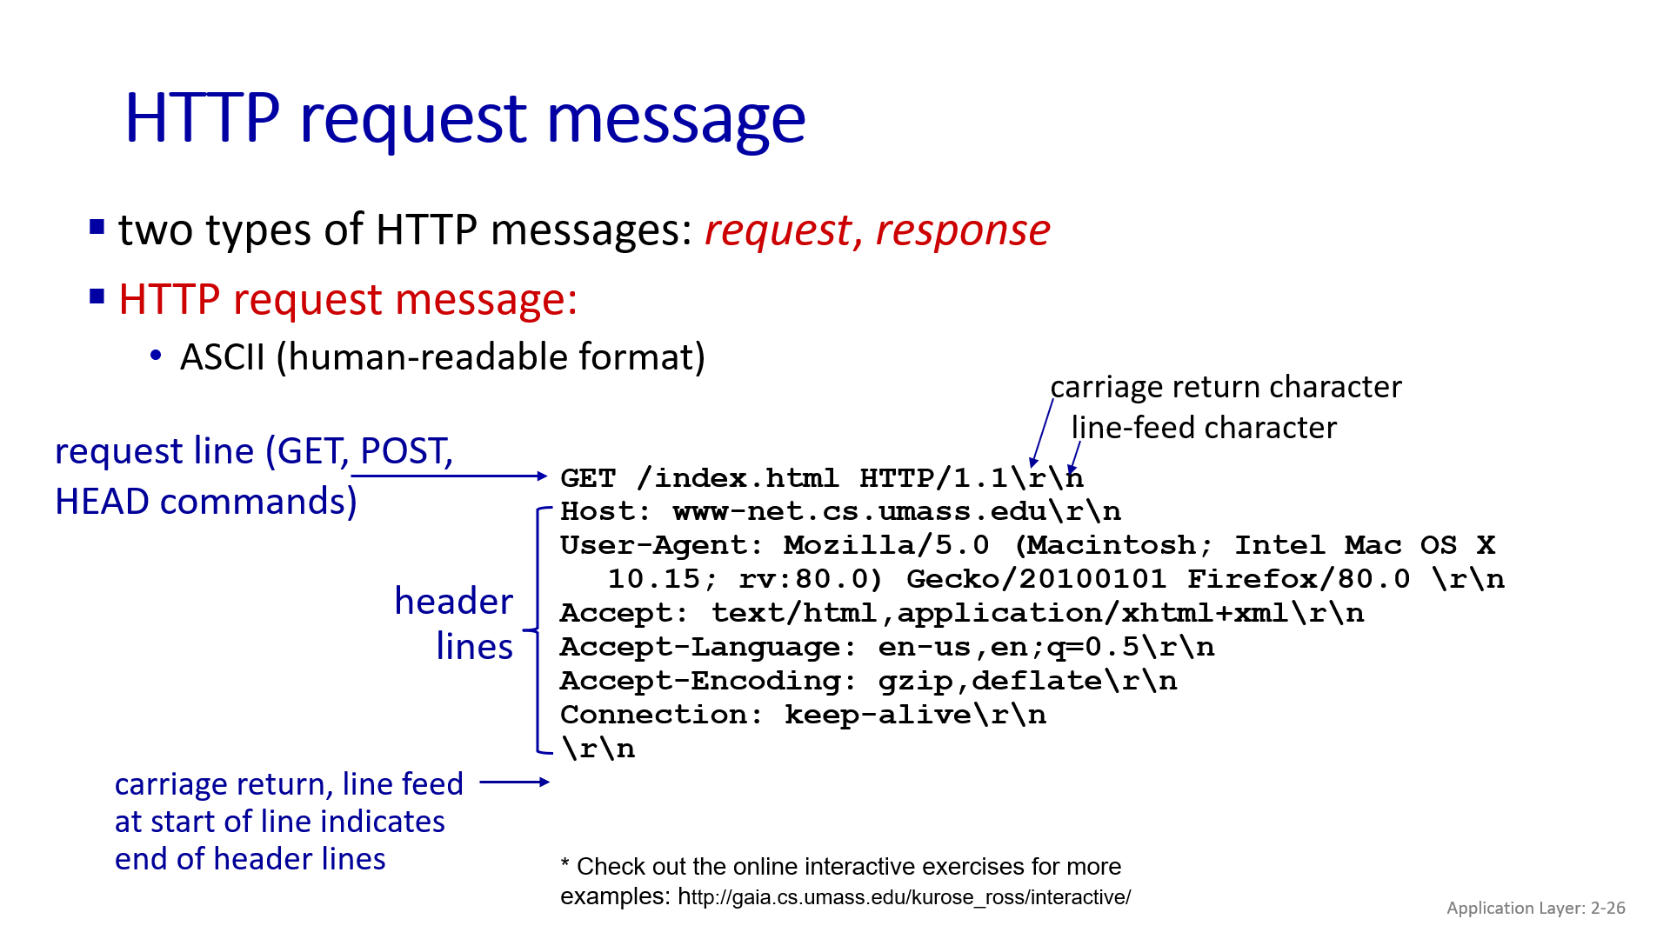
General Format
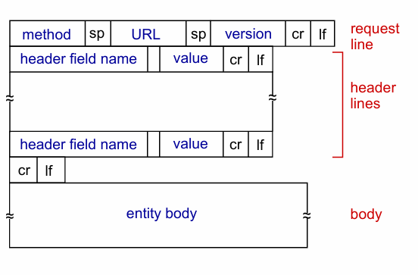

🔄 HTTP Methods
- GET → Request object; parameters can be in URL.
Example:
- www.somesite.com/animalsearch?monkeys&banana
- POST → Send user input in entity body (form submission).
- HEAD → Request only headers (for debugging, cache checking).
- PUT → Upload new object to server (replace file at given URL).

📥 HTTP Response Messages
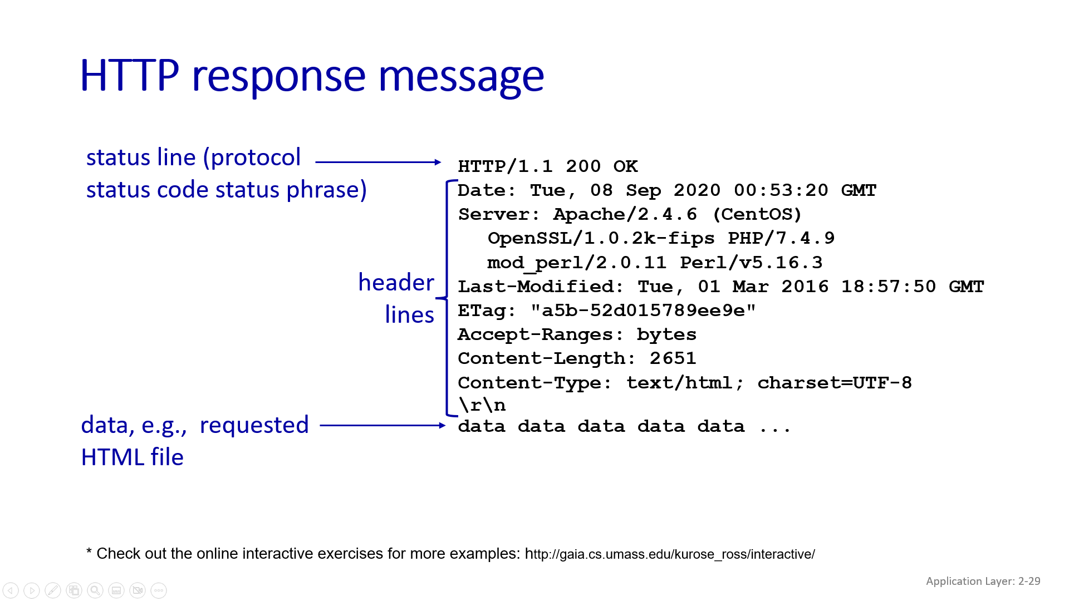
Common Status Codes
- 200 OK → Request succeeded.
- 301 Moved Permanently → Object moved (new location in header).
- 400 Bad Request → Syntax error in request.
- 404 Not Found → Requested object not on server.
- 505 HTTP Version Not Supported.

4.🍪 Maintaining State: Cookies
❗ Problem
- HTTP is stateless → every request is treated like a new one.
- Hard to support things like logins or shopping carts across pages.
✅ Solution: Cookies
Cookies help websites remember users across multiple visits.
🔧 Key Components
- Server sends a cookie in HTTP response.
- Browser stores the cookie file.
- On future visits, browser sends cookie in HTTP request.
- Server uses cookie ID to look up user info in its database.

🌐 Application Layer: Cookies in Web Use
🍪 What Cookies Are Used For
- Login/authentication – keep users signed in.
- Shopping carts – remember items across pages.
- Personalization – show recommendations.
- Session state – keep user activity active (e.g., webmail).

🔐 Cookies and Privacy
Types of Cookies
Type | Who Sets It | Purpose
First-party | Site you’re visiting | Identify returning users
Third-party | Other domains (e.g., ad networks) | Track users across multiple sites for ads
⚠️ Privacy Concerns
- Third-party cookies track your browsing across many websites.
- Browsers are changing:
  - Firefox, Safari: Block third-party cookies by default.
  - Chrome: Planned to block them (starting 2023).

📰 Cookies in Action: NY Times Example
- You visit nytimes.com → it sets a first-party cookie (e.g., 1634).
- Ad from AdX.com loads → AdX sets its own cookie (7493).
- Later, you visit socks.com, which also uses AdX ads.
- AdX sees your cookie (7493) → knows you also visited NY Times.
- AdX shows you targeted ads (e.g., for sports socks).

🇪🇺 GDPR (General Data Protection regulation)and Cookies
- GDPR (EU law) treats cookies, IP addresses, and unique IDs as personal data.
- Requires:
  - User consent before using tracking cookies.
  - Option to allow or block cookies.

5.Web Caches (Proxy Servers)
Goal
- Reduce client response time.
- Reduce traffic load on institution’s access link.
How it Works
- Browser configured to forward all HTTP requests to local cache.
- Cache behavior:
  - If object is cached → return immediately (low delay).
  - If not cached → fetch from origin server → store copy → return to client.
Why Important
- Faster page loads (cache is closer to client).
- Saves bandwidth on external link.
- Helps smaller content providers deliver efficiently (since caches are everywhere).

5. Performance Example
- Scenario:
  - Access link = 1.54 Mbps
  - RTT (router to server) = 2s
  - Object size = 100K bits
  - Request rate = 15 requests per sec
  - Avg throughput = 1.50 Mbps
- Without cache:
  - Access link utilization ≈ 0.97 (almost fully loaded).
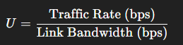
Traffic rate=100,000 bits/request×15 requests/sec=1,500,000 bits/sec=1.5 Mbps
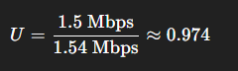
  - High queueing delay → minutes long wait possible.
- Option 1: Buy faster link (154 Mbps) → Expensive solution. U = 0.0974
- Option 2: Use Web Cache (cheap):
  - If cache hit rate = 0.4:
    - 40% requests served instantly (ms delay).
    - Only 60% go to origin server.
    - rate to browsers over access link = 0.6 * 1.50 Mbps = 0.9 Mbps
    - Access link utilization = 0.9 / 1.54 ≈ 0.58 → much lower delay.
    - Avg delay ≈ 1.2s (better than upgrading link!).

6.Browser Caching – Conditional GET
- Goal: Avoid sending unchanged objects.
- Mechanism:
  - Browser request includes:
  - If-Modified-Since: <date>
  - Server checks last modification date:
    - If not modified → responds with 304 Not Modified (no object sent).
    - If modified → sends updated object with 200 OK.

7. HTTP/2 (RFC 7540, 2015)
Problems with HTTP/1.1
- Each connection: FCFS (first come first served).
- Small objects wait behind large ones (Head-of-Line Blocking).
- Packet loss stalls all objects (TCP limitation).
HTTP/2 Improvements
- Same methods/status codes as HTTP/1.1.
- decreased delay in multi-object HTTP requests
- Object priority: Client can prioritize small objects.
- Server Push: Server can send unrequested objects it knows client will need.
- Objects split into frames → interleaving reduces HOL blocking.

8. HTTP/3 and QUIC
Limitations of HTTP/2
- Still on single TCP connection:
  - Loss recovery blocks all streams.
  - No inherent encryption (needs TLS).
  - Browsers still open multiple TCP connections to avoid stalls.
HTTP/3
- Runs over UDP with QUIC.
- Adds:
  - Security (encryption by default).
  - Independent congestion control per stream.
  - Faster connection setup.

9. QUIC (Quick UDP Internet Connections)
Features
- Runs on UDP, application-layer protocol.
- Supports:
  - Reliability, congestion control.
  - Authentication, encryption.
  - Connection state establishment in 1 RTT.
Handshake
- TCP + TLS (old way): Needed 2 handshakes (slower).
- QUIC: Single combined handshake → faster.
0-RTT Resumption
- Client stores a TLS session ticket after first connection.
- Next time → uses stored ticket → 0-RTT secure session establishment.
- Saves round-trip delay → instant reconnection.

6. Emails

2. Email System: Components
- User Agents (UA)
- Mail readers (compose, read, reply, manage).
- Examples: Outlook, Thunderbird, iPhone Mail.
- Emails stored on mail servers.
- Mail Servers
- Store incoming mail in mailboxes.
- Queue outgoing mail.
- Use SMTP to send/receive between servers.
- SMTP (Simple Mail Transfer Protocol)
- Standard for sending emails between servers.
- Uses TCP port 25.
- Client-server model: sender’s server = client; receiver’s server = server.

Mail Server Functions
- Mailbox stores incoming messages.
- Queue holds outgoing messages.
- Sending: sender’s server opens SMTP connection; receiver accepts and stores mail.

SMTP Protocol (RFC 5321)
- TCP port 25, server-to-server delivery.
- Three phases: Handshake (HELO), Message Transfer (headers + body), Closure.
- Commands: HELO, MAIL FROM, RCPT TO, DATA.
- Responses: Status codes (e.g., 220, 250).

5. Example: Sending Email (Alice → Bob)
- Alice composes mail in UA.
- UA sends to Alice’s mail server (SMTP).
- Alice’s server opens TCP with Bob’s mail server.
- Alice’s server sends message.
- Bob’s server stores message.
- Bob retrieves via UA.

6. Example SMTP Interaction
- Server: 220 greeting
- Client: HELO domain
- Server: 250 OK
- Client: MAIL FROM, RCPT TO, DATA commands
- Server: responses (e.g., 354 Enter mail)
- Client: sends message, ends with "."
- Server: 250 Message accepted
- Client: QUIT
- Server: 221 closing connection

7. SMTP Observations
- HTTP pulls objects; SMTP pushes mail.
- Both use ASCII command/response and status codes.
- SMTP supports multiple objects in one multipart message.
- Persistent connections used.
- Messages: 7-bit ASCII; end marked by CRLF.CRLF.

8. Mail Message Format
- SMTP (RFC 5321): email exchange protocol.
- RFC 2822: message syntax (headers like To, From, Subject + body).
- Headers differ from SMTP commands.
- Body is 7-bit ASCII; headers separated from body by blank line.

9. Retrieving Email – Mail Access Protocols
- SMTP sends and delivers mail to receiver’s server.
- Retrieval protocols:
  - IMAP: stores messages on server; supports folders, search, selective retrieval.
  - POP: older, downloads & optionally deletes messages.
  - HTTP webmail: built on SMTP + IMAP/POP (e.g., Gmail, Yahoo).

7.Domain Name System (DNS) – Introduction
Solution: DNS (Domain Name System)
  - Application-layer protocol: hosts & DNS servers communicate to resolve names.
  - Core Internet function but implemented at application layer.
  - Keeps complexity at the network’s edge.

3. DNS Services
- Hostname → IP address translation
- Host aliasing:Canonical name (real name) and alias name (short, easy-to-use).
- Mail server aliasing:
  - Maps email domains to actual mail servers.
- Load distribution:
  - Replicated web servers → one domain name can map to multiple IP addresses.

4. Why Not Centralize DNS?
- Single point of failure → whole Internet breaks if it fails.
- Huge traffic volume → central system can’t handle it.
- Latency issues → a faraway central server would be slow.
- Maintenance difficulties → frequent updates needed.
- Scalability problem:
  - Example: Comcast handles 600 billion DNS queries/day.

5. Nature of DNS
- Humongous distributed database
  - ~Billions of records.
  - Handles trillions of queries/day.
- Read-heavy system
- Performance critical: almost every Internet action (e.g., opening a webpage) involves DNS lookup (milliseconds matter).
- Organizationally decentralized: millions of organizations maintain their own records.
- Reliability & Security critical (“bulletproof”).

6. DNS Hierarchical Database
- Root DNS Servers
  - First contact point, direct queries to TLD servers.
- Top-Level Domain (TLD) Servers
  - Responsible for domains like .com, .org, .edu, .uk, .jp, etc.
  - Examples:
    - Network Solutions → registry for .com and .net.
    - Educause → registry for .edu.
- Authoritative DNS Servers
  - Provide official hostname → IP mappings for an organization’s domains.
  - Maintained by the organization or service provider.
- Local DNS Servers
  - Default DNS server configured by your ISP or organization.
  - Acts as a proxy:
    - Returns cached answers if available.
    - Otherwise forwards queries into DNS hierarchy.
  - Doesn’t belong strictly to the DNS hierarchy.

7. Root Name Servers
- Contact of last resort → used when other DNS servers can’t resolve names.
- Essential for Internet functioning.
- DNSSEC (DNS Security Extensions): provides authentication & message integrity.
- Managed by ICANN (Internet Corporation for Assigned Names and Numbers).
- 13 logical root servers worldwide (replicated many times for scalability & reliability).

8. DNS Name Resolution
a) Iterative Query
- Server replies with “I don’t know, but ask this server.”
- Example: engineering.nyu.edu wants IP of gaia.cs.umass.edu
  - Local DNS → Root DNS
  - Root DNS → TLD server (.edu)
  - TLD server → Authoritative server (umass.edu)
  - Authoritative → Final IP returned.
b) Recursive Query
- Burden placed on the contacted server → it resolves the query fully on behalf of the client.
- Drawback: high load at upper hierarchy levels.

9. Caching in DNS
- Once a mapping is learned, it’s cached locally.
- Cache entries expire after TTL (Time-to-Live).
- Problem: may be outdated if the host changes IP before TTL expiry → inconsistent state possible.
- DNS provides best-effort name resolution, not always perfectly up-to-date.

10. DNS Resource Records (RRs)
- Format: (name, value, type, TTL)
- Type = A: hostname → IP address
- Type = NS: domain → authoritative name server
- Type = CNAME: alias → canonical name (real hostname)
  - Example: www.ibm.com → servereast.backup2.ibm.com
- Type = MX: domain → mail server

11. DNS Protocol Messages
- Same format for query and reply.
- Fields include:
  - Identification (16-bit): same in query and reply (for matching).
  - Flags:
    - Query/reply
    - Recursion desired / recursion available
    - Reply is authoritative
  - # of questions, # of answer RRs, # of authority RRs, # of additional RRs.
- Sections:
  - Questions → what client asked.
  - Answers → resolved RRs.
  - Authority → authoritative servers.
  - Additional → helpful extra info.

12. Registering a New Domain (Example: NetworkUtopia.com)
- Register networkutopia.com with a registrar (e.g., Network Solutions).
- Provide names and IPs of authoritative servers (primary & secondary).
- Registrar inserts records into TLD servers:
  - (networkutopia.com, dns1.networkutopia.com, NS)
  - (dns1.networkutopia.com, 212.212.212.1, A)
- Create authoritative server locally:
  - Type A record for www.networkutopia.com.
  - Type MX record for networkutopia.com.

13. DNS Security
- DDoS Attacks
  - Target root servers → mitigated by replication & caching.
  - Target TLD servers → more dangerous.
- Spoofing Attacks
  - Intercept queries and inject bogus replies.
  - DNS Cache Poisoning: inserting false mappings into DNS caches.
- DNSSEC (RFC 4033)
  - Provides authentication & integrity for DNS messages.

8.Application Layer – Video Streaming & Content Distribution Networks (CDNs)

1. Context
- Video streaming dominates Internet traffic:
  - Netflix, YouTube, Amazon Prime, etc. → ~80% of residential ISP traffic (2020).
- Key Challenges:
  - Scalability: How to deliver video to ~1B+ users?
  - Heterogeneity: Users have different devices, network conditions, and bandwidth availability (wired vs mobile, bandwidth-rich vs bandwidth-poor).
- Solution: Distributed, application-level infrastructure (e.g., CDNs, adaptive streaming).

2. Multimedia: Video Basics
- Video = sequence of images shown at constant rate (e.g., 24 fps, 30 fps).
- Digital image: array of pixels; each pixel = bits representing color/intensity.
Compression (Coding)
Used to reduce bits needed per frame. Two main types:
- Spatial Coding (within an image):
  - Remove redundancy inside a single frame.
  - Example: Instead of sending N repeated purple pixels → send {color = purple, count = N}.
- Temporal Coding (across frames):
  - Exploit similarity between consecutive frames.
  - Example: Send only differences between frame i and frame i+1, not the whole frame.

3. Video Encoding
- CBR (Constant Bit Rate)
  - Fixed encoding rate.
  - Simpler but may waste bandwidth when scene changes are small.
- VBR (Variable Bit Rate)
  - Rate changes depending on spatial/temporal complexity.
  - More efficient, adjusts to video content.
Encoding Standards (examples)
- MPEG-1 (CD-ROM): ~1.5 Mbps
- MPEG-2 (DVD): 3–6 Mbps
- MPEG-4 (Internet): 64 Kbps – 12 Mbps

4. Streaming Stored Video
- Scenario: Server stores video, streams to client over Internet.
- Challenges:
  - Bandwidth between server & client varies over time (due to congestion at home, access network, core network).
  - Packet loss & delays → can break smooth playback.

5. Streaming Timeline
- Video recorded (e.g., 30 fps).
- Sent over the network.
- Received at client & played out at 30 fps.
- Streaming nature: Client may play earlier part of video while server is still sending later part.

6. Challenges in Streaming
- Continuous playout constraint:
  - Playout timing must match original video rate.
  - Problem: Network jitter (variable delay).
  - Solution: Client-side buffer smooths playback.
- Client interactivity:
  - Functions like pause, fast-forward, rewind, jumping need to be supported.
- Packet loss/retransmission:
  - Loss = degraded quality (blocky images, freezes).
  - Retransmission may cause delay.

7. Playout Buffering
- Client introduces playout delay to build a buffer.
- Example:
  - At time t0, client has received 6 chunks, played 2, so 4 remain in buffer.
- Buffer helps:
  - Absorb jitter (variable delay).
  - Avoid starvation (video freezing).
- Tradeoff:
  - Larger buffer → smoother playback but higher startup delay.

8. DASH (Dynamic Adaptive Streaming over HTTP)
- Server Side:
  - Splits video into chunks.
  - Each chunk encoded at multiple bit rates.
  - Chunks stored on CDN nodes.
  - Provides a manifest file listing URLs of chunks at different qualities.
- Client Side:
  - Estimates available bandwidth.
  - Requests chunks one-by-one, choosing encoding rate accordingly.
  - Can adapt:
    - Higher quality when bandwidth high.
    - Lower quality when bandwidth drops.
  - Can fetch chunks from different servers (close or less congested).
- Intelligence at Client:
  - Decides when to request a chunk.
  - Decides what quality to request.
  - Decides where (which CDN node) to fetch from.
Streaming Video = Encoding + DASH + Playout Buffering

9. Content Distribution Networks (CDNs)
Challenge
- Need to deliver millions of videos to hundreds of thousands of users simultaneously.
Option 1: Mega-server approach
- One large server stores all videos.
- Problems:
  - Single point of failure.
  - Network congestion bottleneck.
  - Long paths to distant users.
  - Does not scale.
Option 2: Distributed CDN approach
- Store multiple copies of videos at geographically distributed sites.
- Two strategies:
  - Enter Deep
    - Deploy CDN servers inside many ISPs’ access networks.
    - Pros: Very close to users → low latency.
    - Example: Akamai with 240,000+ servers in >120 countries (2015).
  - Bring Home
    - Fewer but larger CDN clusters at strategic locations (Points of Presence, POPs).
    - Example: Limelight Networks.

10. Case Studies
- Akamai
  - Large-scale CDN with massive distributed infrastructure.
  - Subscribers request content → service provider returns a manifest file.
- Netflix
  - Uses OpenConnect CDN (its own CDN).
  - Stores copies of shows (e.g., Mad Men) at OpenConnect nodes globally.
  - Client retrieves content at highest sustainable rate.
  - If congestion occurs → can switch rate or server location dynamically.

11. OTT (Over-the-Top) Challenges
- OTT = services delivered over the public Internet, not private ISP networks.
- Challenges:
  - Deciding which CDN node should hold which content.
  - Deciding from which CDN node client should retrieve.
  - Choosing what bitrate client should request (depends on conditions).

9. Socket Programming

2. Socket Programming Overview
Goal: Build client/server applications communicating via sockets.
Socket: Acts like a door between an application process and the transport protocol. Controlled by OS and the application developer.

2.1 Types of Sockets
- UDP Socket
- Unreliable, connectionless datagram service.
- No handshaking; sender explicitly attaches IP address and port for each packet.
- Data may be lost or arrive out-of-order.
- Provides unreliable datagram transfer between client and server.
- TCP Socket
- Reliable, connection-oriented byte stream service.
- Requires handshaking (connection setup).
- Guarantees reliable, in-order delivery of bytes.
- Server can handle multiple clients by creating a new socket per client.
- Provides reliable, ordered byte-stream transfer ("pipe") between client and server.

2.2 UDP Socket Programming Example
- Client creates a UDP socket, sends a message to a server (using server name and port), receives a reply, and closes the socket.
- Server creates a UDP socket, binds to a port, and continuously receives messages, processes them (e.g., converts to uppercase), and sends back responses.

2.3 TCP Socket Programming Example
- Client creates a TCP socket, connects to a server, sends data, receives a reply, prints it, and closes the connection.
- Server creates a TCP socket, binds to a port, listens for incoming connection requests, accepts a connection, receives data, sends a response, and closes the connection.

3. Socket Timeouts & Exceptions
- Networking often requires timeouts to avoid infinite waits or enable retransmissions.
- Python’s settimeout() method sets a maximum wait time for socket operations; if exceeded, a timeout exception is raised.
- Using try-except blocks allows graceful handling of timeout exceptions.
- Example analogy: A shepherd boy connects to a server but doesn’t send data; after several timeouts, the listeners stop responding permanently.

4. Protocols Recap
4.1 SMTP Email Interaction
- The client-server exchange involves commands like HELO, MAIL FROM, RCPT TO, DATA, and QUIT, with server responses using status codes (e.g., 220, 250).
4.2 CDN Content Delivery Example
- When a user clicks on a video link, DNS resolves the domain to a CDN server, which streams the video to the user via HTTP.
4.3 Netflix Case Study
- Netflix uses Amazon Cloud for account management.
- Videos are stored on CDN servers with multiple quality versions.
- The client fetches a manifest file listing video chunks and streams the video adaptively via DASH (Dynamic Adaptive Streaming over HTTP).

Tutorial Questions
1.(5 points) Suppose that there are two hosts (A and B) separated by a distance of 1,000 KM and connected by a direct point-to-point link of capacity, R=1 Mbps. Assume the propagation speed of light over the link as 2.5x10 m/s. What is the Delay Bandwidth Product of this link? Consider sending a file of 40,000 bytes on the same link where the file is sent as one big message. How long does it take to transfer the file and what is the achieved throughput? What is the maximum number of bits that will be in the link at any given time? and What is the width (in meters) of a bit in the link?
2.(3 points) Consider sending the same file from Host A to Host B described in the previous question, but the file is now broken up into 10 equal-sized packets and each packet is acknowledged by the receiver (Host B) and the transmission time of the acknowledgment packet is negligible, as it is a very small packet. If the sender cannot send a packet until the preceding packet is acknowledged, how long does it take to send the file? What is the achieved throughput?
3. (4 points) Assume that the packet size is L bits, the transmission rate of each link is R bps, the length of each link is D meters, and the speed of light is S meters/second. Then, what is the total delay incurred in transmitting P packets back-to-back from the source to the destination over N links in case of the Store-and-forward switching and Pass-through switching?
4. (8 points) The base HTML page to be downloaded from a web server is 5 KB in size and it references 10 other objects each of size 100 KB. The RTT between the host and the web server is 250 msec. The 10 referenced objects are hosted on a nearby CDN server which has an RTT of 50msec from the host. Assume that the available data rate between the host and the Web server is 10 Mbps, while it is 50 Mbps for the CDN server. Assume that there are no additional overheads for the HTTP headers. The time required to setup TCP connections using the three-way handshake is 1 RTT. Note that the bandwidth is equally shared between TCP connections when running in parallel. Calculate the time required for the host to download all the required objects for the browser to render the page for the following scenarios. a) Non-persistent HTTP and no parallel TCP connections, b) Non-persistent HTTP with 5 parallel TCP connections, c) Persistent HTTP without parallel TCP connections, and d) Persistent HTTP with 5 parallel TCP connections.
5. (4 points) What is the speed up in the response time due to usage of the CDN server for each of the cases (described in the earlier question) vis-a-vis no CDN (ie., all objects are hosted on the website itself)?

https://chatgpt.com/c/68c1aaa0-bd80-8333-a7b5-6a9a09ae7a48

